**Friday, April 19**

**UB Student Vendor Expo 2013**  
12 noon - 6:00pm

105 Harriman Hall, UB South Campus

Main Street & Bailey Avenue, Buffalo, NY

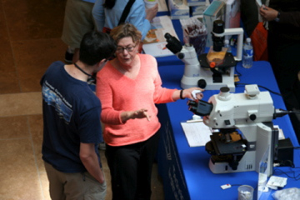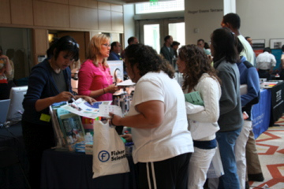

**What is the cost, and what is included in your registration?**

* Your registration includes an approximately six-foot table $995
* Space is limited, and priority spaces will be assigned to vendors at a first come, first served basis - so sign up early!
* We will provide snacks & beverages throughout the day — eat at your showcase booth, or in a vendors-only area
* We will provide a complete list of event registrants

|  |  |
| --- | --- |
| mage of UCSF Vendor Showcasemage of UCSF Vendor Showcase | **We Can Assure You a Great Turnout!**   * + - Because this is a UB sponsored event, we can assure you the best possible exposure of your products and services to our students & scientific community.     - We will mount an extensive publicity campaign on campus, to our Alumni and throughout Western New York, using e-mail lists only available to internal UB sponsors. Also, the CE event featuring prominent UB lecturers will attract faculty, staff, postdocs, technicians and private practice dentists to your booth.     - Once they are at the event, attendees will be able to obtain prizes, food and drinks for visiting vendors' booths, so be sure to bring plenty of materials to distribute! |

**Questions?**

Contact **Annamarie Phalen** Associate Director, CDE, aphalen@buffalo.edu, 716.829.2320  
or **Matt Valerio** UBSDM Class of 2014, ASDA Fundraising Chair, mlvaleri@buffalo.edu, 585.729.2014