http://www.referent-tracking.com/RTU/images/UBDentalSchoolLogo.gif

315 Squire Hall

RE: BOCA

3435 Main Street

Buffalo, NY 14214

March 4, 2014

To Our Supportive Alumni,

Each year, the students of University at Buffalo School of Dental Medicine host a charity auction with proceeds donated to worthy causes in the community. This year, we are donating to Buffalo Outreach and Community Assistance (BOCA) and Remote Area Medical (RAM). **Please consider partnering with us to support these organizations.**

BOCA was established by dental students in 2003 with the goal of providing care to underserved areas. Since 2004, faculty and students have delivered much needed dental treatment to such locations as Appalachia, Belize, Dominican Republic, Fiji, Ghana, Guatemala, Mexico, and Vietnam in addition to serving our own local community. This year, the student-run program has scheduled outreach to take place in the Dominican Republic, Fiji and rural Tennessee, as well as events here in Buffalo and Rochester. Free services offered include dental education, oral examinations, mouth guard fabrication, periodontal scaling and oral prophylaxis, amalgam, glass ionomer and resin composite restorations, endodontic procedures and routine and surgical exodontia. Our program is recognized by the University and has been acknowledged by the American Dental Association as a successful organization aimed at providing oral health care to those in need. **This year, a portion of our auction proceeds will stay with BOCA and will be used to purchase dental supplies and equipment and help support the costs assumed by student and faculty volunteers.**

Remote Area Medical Volunteer Corps is a non-profit, volunteer, airborne relief corps dedicated to serving mankind by providing free health care, dental care, eye care, veterinary services, and technical and educational assistance to people in remote areas of the United States and the world. Founded in 1985, RAM is a publicly supported all-volunteer charitable organization. Recently, BOCA has teamed with RAM missions in rural Tennessee and Kentucky to provide faculty and student volunteers from the UBSDM. Free services offered on these weekend-long trips include dental education, oral examinations, periodontal scaling and oral prophylaxis, amalgam, glass ionomer and resin composite restorations, and routine and surgical exodontia. **This year, a portion of our auction proceeds will be donated to RAM to be used to cover general mission trip expenses.**

Our 6th Annual Charity Auction will take place this year on **March 28, 2014.** Any items, products, or services that you are willing to donate for the auction will be greatly appreciated. In the past, alumni have donated such items as themed gift baskets, gift certificates, time-shares and homemade items. If you so chose to donate to our auction, we ask that all donation items be in by **March 25, 2014**. You can also show your support by attending the auction that will take place in Harriman Hall at 6:30pm. Tickets are $15 presale or $20 at the door and can be purchased by cash or check (made out to UB Foundation: BOCA). Donations and/or ticket money may be mailed to “BOCA” at the address above.

We have been very fortunate to be involved with the many outreach opportunities we have had and your support will allow us to continue these outreach efforts in the future. **Please help us to ensure BOCA and RAM are able to work towards their missions of providing care to the underserved by donating to our charity auction.** Please consider this a receipt for any generous contribution for tax-deductible purposes. Our New York State tax-exempt number is 198278.

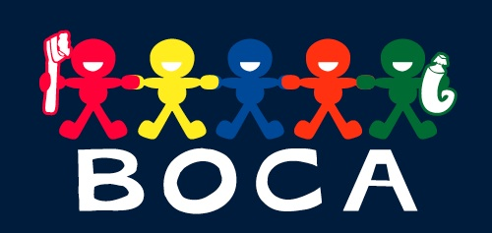

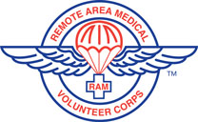

If you are interested in learning more about the BOCA program and for outreach pictures and videos please refer to our website <https://dental.buffalo.edu/CommunityOutreach/BOCA.aspx>. Please email [bocaub@gmail.com](mailto:bocaub@gmail.com) with any questions/inquires.

Thank you kindly for your time and consideration,

Dustin Plunkett & Solomia Zhownirovych - BOCA Fundraising Officers